Start Script & Step 1:

Step 2:

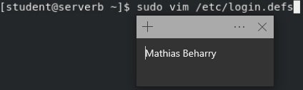

Step 3:

Step 4:

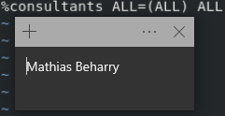

Step 5:

Step 6:

Step 7:

Step 8:

Evaluation Script & Finish Script:

